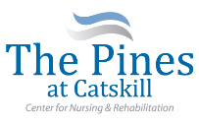
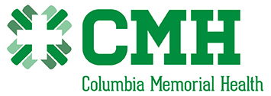

Are pleased to present a
Stroke Survivor and Caregiver
Monthly Support Group
Held every 2nd Wednesday at 3:00 P.M.
At
The Pines at Catskill Center for Nursing & Rehabilitation
154 Jefferson Heights
Catskill, New York 12414
|
Learn more about the following topics in a relaxed and caring environment
      - Overview of strokes
      - Signs, symptoms and types
      - Adaptive equipment and their uses
      - Coping skills – caregiver burn-out
      - Open forum – sharing ideas, thoughts and concerns
      - Available resources

All are welcome!

For questions call: (518) 943-5151

