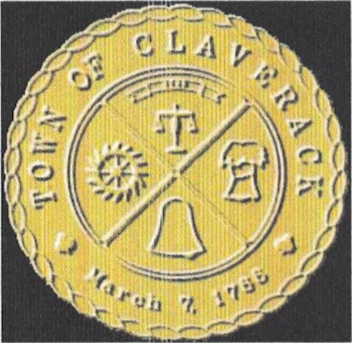
TOWN OF CLAVERACK
Building Department 91 Church Street, PO Box V
Mellenville, NY 12544
PHONE 518-672-4471 / FAX 518-672-4821
ELECTRICAL INSPECTION AGENCIES ANDINSPECTORS
FOR THE TOWN OF CLAVERACK

Atlantic Inland, Inc.
William Jacox
(800) 758-4340
Lagrangeville, NY 12540
Middle Department Inspection Agency
Anthony Sibage
(800) 873-6342
New York Electrical Inspections
Tom LeJeune
(845) 373-7308
(845) 373-7309 Fax
NYEI.Tom@optonline.net
All County Electrical Insurance Services
David F. Scism
(845) 757-5916
Tri-State Inspection Agency
Al Shauger
(845) 986-6514)
State Wide Inspection Services
Frank Farina 845-202-7224
Northeast Electric
Dave Near
518-852-0826
The Inspector
David P. Smith
800-487-0535

Z3 Consultants Inc
Gary E. Beck, Jr. P. O. Box 363
845-471-9370/845-345-9843
NY Electrical Inspections & Consulting
John Wierl
(845) 343-6934
NYB-New York Board
Pat Decina
(845) 298-6792
The Inspector, LLC
Andrew Barabas
260 Central Ave
New Rochelle, NY 10805 (914) 438-3859
Swanson Consulting Inc. P.O. Box 395
Salisbury Mill, NY 12577
(845) 496-5160
Middle Department Inspection Agency
Dave Williams
(518) 368-3767
Commonwealth Electrical Services Bruce Fairweather
518-766-5547 / 518-567-7400 (Cell)

